

RTMP – Live Streaming with

Cloud Integration

Name : Niraj Chaudhari, Samarth Pansala, Himanshu Parghi

Roll no.: 22bce209, 22BCE220, 22BCE222

Course : Cloud Computing

Course Code : 3cs402cc24

Innovative Assignment - Report

Project Github Link: [RTMP Live Streaming Platform with Cloud Integration](https://github.com/pansalasamarth/RTMP-Live-Streaming-with-Cloud-Integration)

# Introduction:

This report introduces a cutting-edge cloud-based live streaming platform designed as a Software as a Service (SaaS) solution. The project leverages modern web technologies to deliver an interactive and scalable environment, where users can seamlessly broadcast and consume real-time video content. Built on a robust Node.js backend and enriched with a responsive JavaScript frontend, the platform employs Docker-managed TURN servers to ensure reliable connectivity and efficient media relay across diverse network conditions. This cloud-centric architecture not only enhances performance and scalability but also simplifies deployment and management, making it an ideal solution for enterprises seeking flexible, high-performance streaming services in a SaaS model.

# Technologies Used:

* **Frontend Development**:
* Utilizes modern JavaScript React frameworks to build a dynamic, responsive, and user-friendly interface.
* **Backend Development**:
* Developed using Node.js and Express.js ensuring a robust server environment capable of handling real-time data and streaming.
* **Real-Time Communication**:
* Implements WebRTC and WebSockets for seamless, low-latency media transmission and signaling between peers.
* **Cloud & SaaS Architecture**:
* The entire platform is designed as a cloud-based Software as a Service (SaaS), offering easy scalability and streamlined management. We use infrastructure as a service (IaaS) , which is provided by AWS EC2 (Elastic compute cloud).
* **Containerization & Networking**:
* Uses Docker to deploy a TURN server, which assists in network traversal and media relay, enhancing connectivity across different network conditions.

# Features:

* **Live Streaming with WebRTC**:
* Enables real-time, video and audio streaming between a publisher (stream host) and viewers.
* **Frontend Application**:
* **Home Page**:
* Displays a list of active streams with stream’s Publisher ID and their entered name with search functionality.
* Provides navigation to start a new stream.
* **Publisher Interface**:
* Captures local media (video/audio) for live streaming.
* Establishes multiple peer connections to serve connected viewers.
* Displays a live preview and a dashboard with connected viewers with their names and status logs.
* Multiple Publisher can stream simultaneously and Viewer can choose any one of them.
* **Viewer Interface**:
* Allows users to join a live stream by connecting to a publisher.
* Manages WebRTC connection setup to receive and display the live stream.
* **Signaling and Communication**:
* WebSocket Signaling Server:
* Manages the exchange of WebRTC signaling messages (offers, answers, ICE candidates) between publishers and viewers.
* REST API Endpoints:
* /streams : Provides a list of active streams.
* /ice-config : Supplies ICE server configuration details (STUN/TURN servers) for connection establishment.
* **Secure and Scalable Server Architecture** :
* Runs on an HTTPS Express server with SSL/TLS certificates for secure communication.
* Uses environment variables to configure server parameters like port numbers, STUN/TURN servers, and signaling paths.
* **AWS EC2 Infrastructure Integration** :
* Cloud Deployment:
  + Robust Infrastructure :

Deployed on AWS EC2, providing a resilient and scalable infrastructure for hosting the live streaming application.

* + Scalability and Flexibility:

Leverages the flexibility of AWS EC2 to dynamically scale resources based on demand, ensuring smooth performance during traffic peaks.

* + High Availability:

Utilizes AWS’s reliable infrastructure to achieve high uptime and quick recovery from any potential failures.

* + Security and Compliance:

Benefits from AWS’s comprehensive security measures, ensuring that our application remains secure and compliant with industry standards.

* + Optimized Cost Management:

AWS EC2's pay-as-you-go model enables cost-effective resource allocation,

ensuring that you only pay for what you use.

Implementation:  
 Code Files Structure:   
 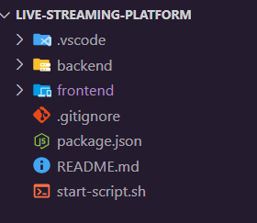

**Folders:**

* **.vscode** : Configuration for Visual Studio Code (settings, extensions, etc.).
* **backend & frontend**: Clear separation of server-side and client-side code.

**Files**:

* **.gitignore :** Exclusion rules for Git at the project root.
* **package.json** : Could be a root-level package definition to manage scripts for both frontend and backend.
* **README.md**: Documentation or instructions for the project.
* **start-script.sh**: A shell script to run or set up the project (possibly starts both frontend & backend).

Backend Part Structure:  
 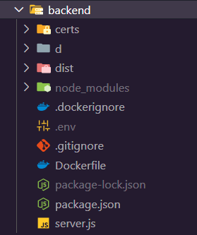  
  
**Folders:**

* **certs**: Likely holds SSL certificates or related security files.
* **d and dist**: Could be custom or build output folders.
* **node**_**modules**: Standard Node.js dependencies folder.

**Files:**

* **.dockerignore & Dockerfile:** Indicates Docker is used for containerizing the backend.
* **.env:** Contains environment-specific variables (likely not tracked in version control).
* **.gitignore:** Standard file to exclude certain files/folders from Git.
* **package.json & package-lock.json:** Node.js project definition and locked dependency tree.
* **server.js:** Probably the main server entry point (e.g., Express.js).

#### file: server.js

1. **Environment Configuration for Cloud Settings:**

* **Loading Environment Variables:**

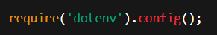

This allows the application to be configured dynamically using environment variables, a common cloud practice. In cloud environments, settings such as port numbers, hostnames, and third-party service credentials (e.g., for ICE, STUN, and TURN servers) are typically managed via environment variables.

* **Configurable Ports and Endpoints:**

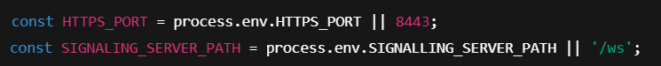

This makes the application adaptable to different deployment environments (e.g., production, staging) where ports or URL paths may be specified externally.

1. **Secure Server Setup :**

* **HTTPS Server with SSL/TLS:**

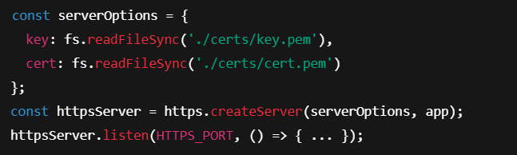

Running over HTTPS is essential in cloud deployments to secure data in transit. This code reads SSL certificates from files, ensuring encrypted communication—a key requirement when services are hosted in the cloud.

1. **REST Endpoint for ICE Server Configuration:**

* **ICE Configuration for WebRTC:**

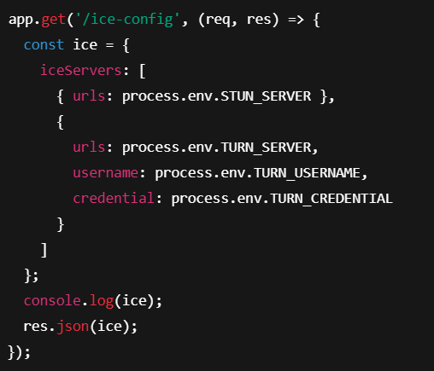

This endpoint provides ICE server details, which are critical for NAT traversal in peer-to-peer communications. Cloud deployments often rely on configurable STUN/TURN services to ensure reliable connectivity across various network conditions.

1. **WebSocket Integration for Real-Time Communication:**



Attaching the WebSocket server to the HTTPS server enables secure, real-time signaling—a common requirement in cloud-based applications, especially those facilitating WebRTC connections. This setup supports dynamic, low-latency communication between distributed clients.

Frontend Part Structure:  
 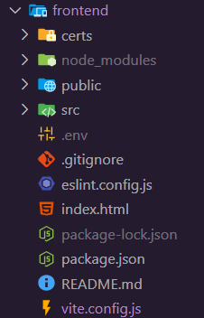  
  
**Folders:**

* **certs:** Again, possibly holds SSL certificates for local HTTPS or similar.
* **node_modules**: Dependencies for the frontend.
* **public & src**: Typical structure for modern frontend frameworks (e.g., React, Vue, etc.).

**Files:**

* **.env**: Environment variables for the frontend build.
* .**gitignore**: Ignores frontend-specific files/folders.
* **eslint**.config.js: ESLint configuration for code linting.
* **index**.**html**: Main HTML entry point for the frontend.
* **vite**.**config**.**js**: Indicates the frontend is using Vite for development/build.
* **package**.**json** **&** **package-lock**.**json**: Defines and locks frontend dependencies.

#### file: start-script.sh

1. **Dynamic Environment Configuration:**
   * **Fetching the Public IP:**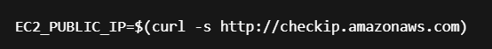In a cloud environment like EC2, obtaining the current public IP dynamically ensures that configuration files use the correct external address.
   * **Creating Environment Files:**

The script creates and writes to .env files for both the frontend and backend:

* + **Frontend:  
    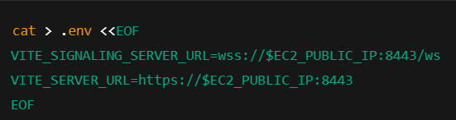**

This configures the frontend to connect to the signaling server using the correct public IP and secure WebSocket URL

* + **Backend:**

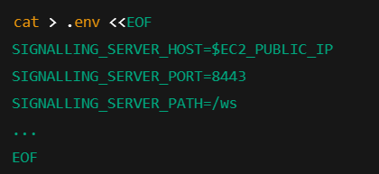

The backend’s .env file is similarly configured, including details for STUN/TURN servers used inWebRTC communication, ensuring proper cloud connectivity.

1. **Building and Deploying the Frontend:**

* **Building the Frontend:**



The script builds the frontend project (likely using a modern framework like Vite). This step is crucial to prepare the production-ready assets for cloud deployment.

* **Copying Build Artifacts:**

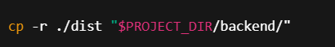

After building, the distribution folder is copied into the backend directory, ensuring the server can serve the static files in the cloud environment.

1. **Docker Container Management for TURN Server:**

* **Ensuring Docker is Running:  
  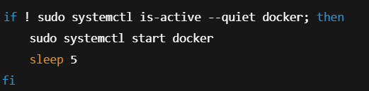**

This check guarantees that the Docker daemon is active, which is essential when deploying containers on cloud instances.

* Managing the Coturn Container:  
  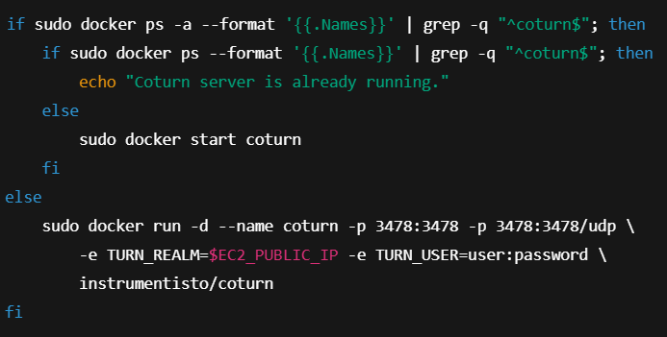
  + TURN Server:

Coturn is a TURN server that helps with NAT traversal in WebRTC applications. Running it as a Docker container simplifies deployment on cloud instances and ensures reliable, scalable real-time communication.

1. **Launching the Backend Server:**

* **Starting the Server:**

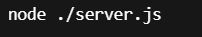

Finally, the script launches the Node.js backend server, making the signaling and REST endpoints available for clients. Running this as part of the deployment script is typical in cloud environments to ensure the service is live after setup.

* **In summary, the script is designed for a cloud (EC2) environment by:**
* Dynamically configuring environment variables with the instance's public IP.
* Preparing and deploying both frontend and backend applications.
* Managing a Dockerized TURN server (coturn) for robust WebRTC connectivity.
* Ensuring that all critical services are started in the correct order for a successful cloud deployment.

This careful orchestration is vital for maintaining a secure, reliable, and scalable live-streaming platform in the cloud.

Flow diagram:  
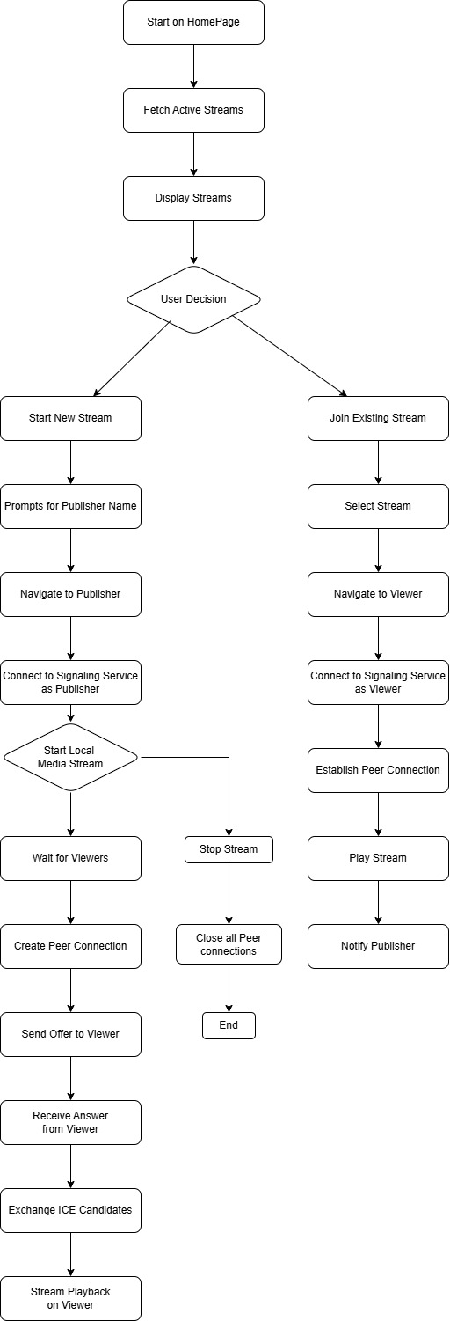

Sequance Diagram:  
  
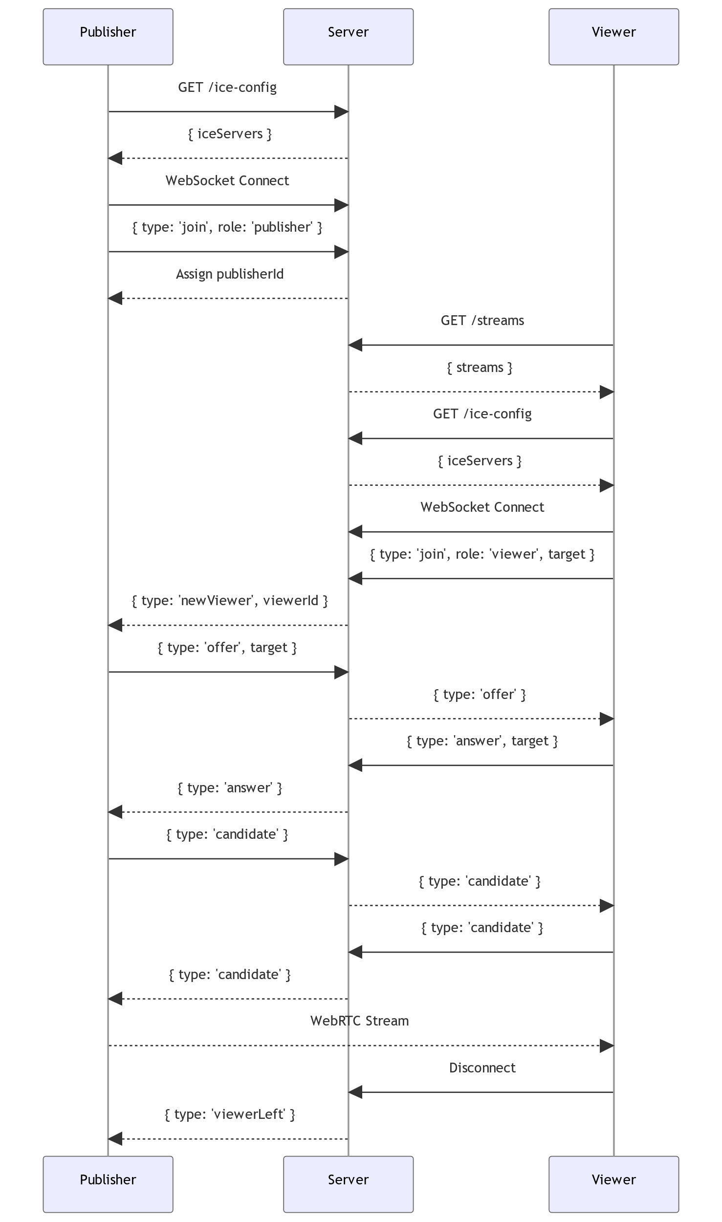

Architecture Diagram:

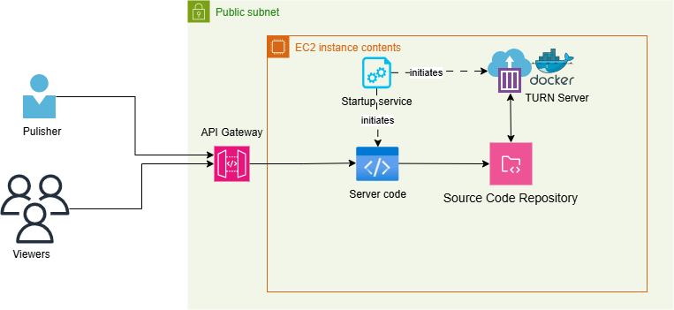

Create EC2 instance on AWS :  
  
1) ec2 instance creation:   
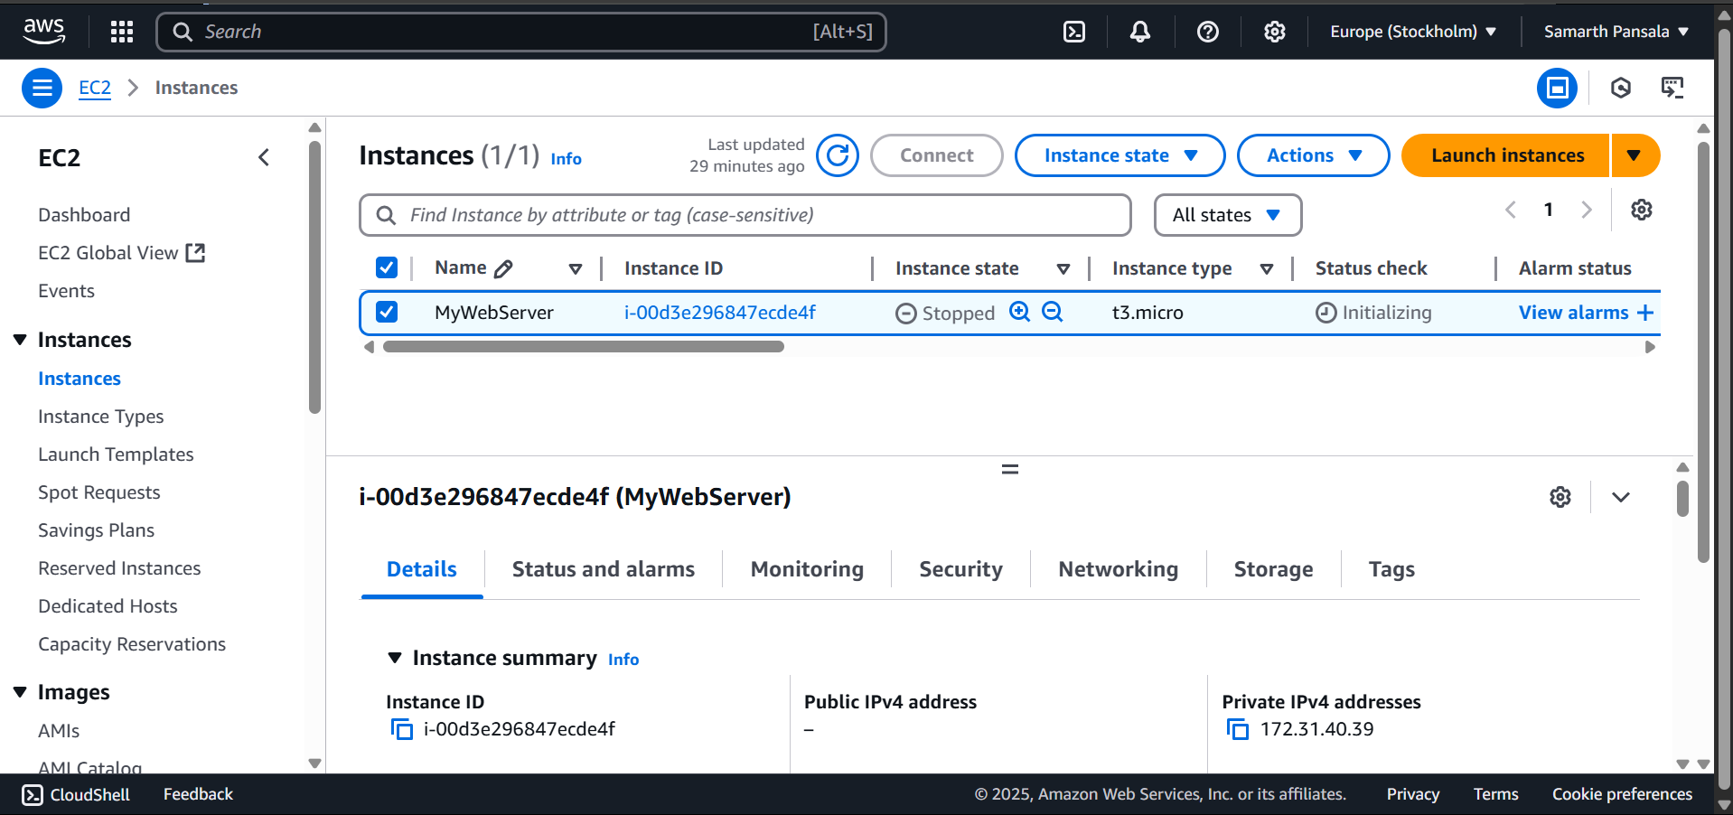  
  
2) modify Security group:   
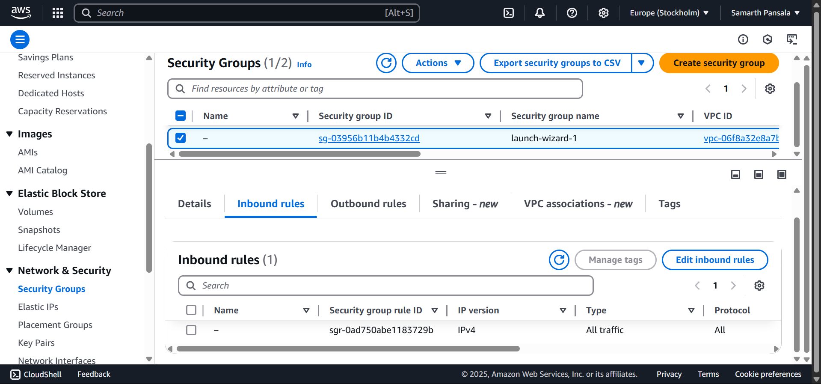

3) connect with EC2 instance:

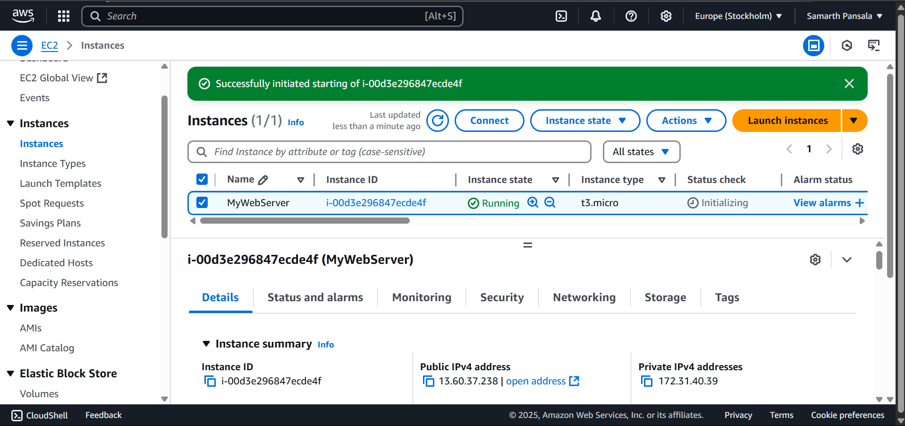  
  
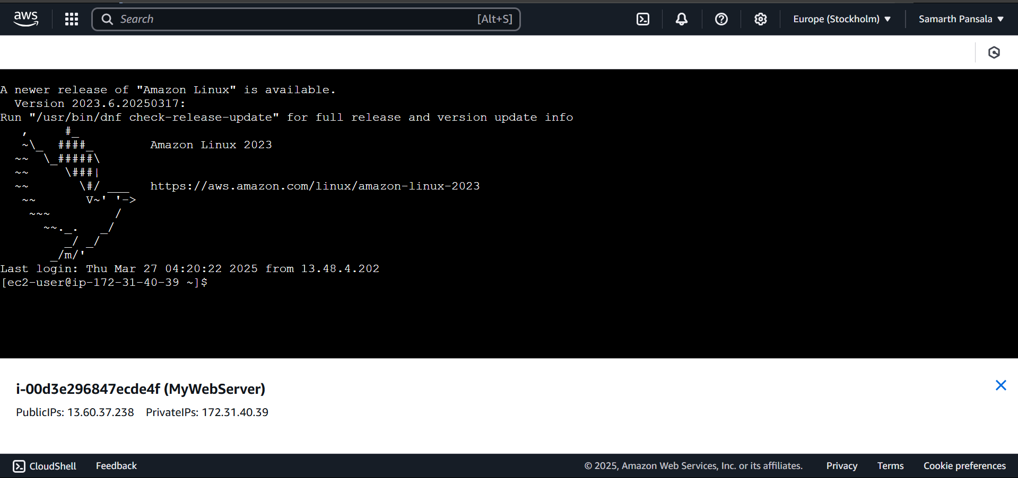  
  
Write all following commands into EC2 connect terminal  
  
**1. Installing Node.js Using NVM**

* **Commands:**

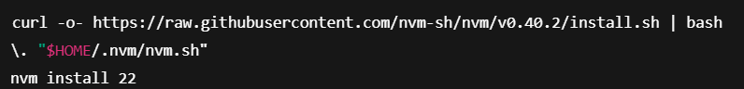

* **Explanation:**
  + **NVM Installation:** Installs Node Version Manager (NVM) which makes managing multiple Node.js versions easier.
  + **Node.js Installation:** Installs Node.js version 22, ensuring the correct runtime environment for the application.

**2. Installing Git**

* **Command:**



* **Explanation:**
  + Installs Git, a version control system required for cloning the repository containing the project source code.

**3. Cloning the Repository**

* **Command:**



* **Explanation:**
  + Clones the GitHub repository to the local cloud instance, ensuring that you have the latest code for deployment.

**4. Setting Script Permissions**

* **Command:**



* **Explanation:**
  + Makes the startup script executable, which is necessary for running the script that initializes and manages the application services.

**5. Creating a Systemd Service**

* **Command:**



* **Explanation:**
  + Opens a new file for a systemd service. This service file is used to define how the application should start, restart on failure, and run under a specific user and working directory.
* **Service File Configuration:  
  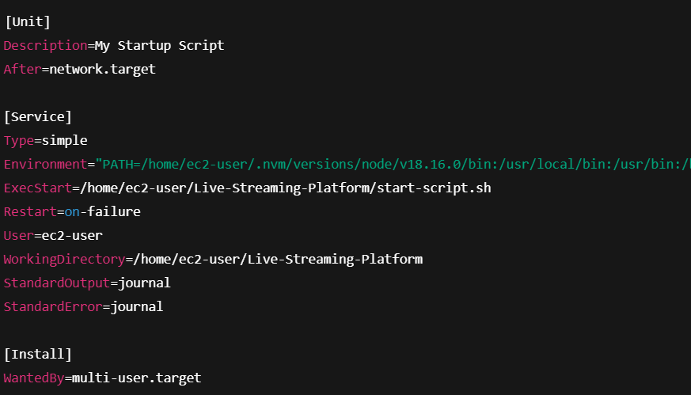**

**Key Points:**

* + - **ExecStart:** Runs the startup script.
    - **Restart=on-failure:** Automatically restarts the service if it fails.
    - **User & WorkingDirectory:** Specifies the user and directory context.
    - **Environment PATH:** Ensures the correct Node.js version is used.

**6. Installing Dependencies**

**Installing Dependencies**

* **Commands:**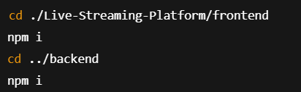
* **Explanation:**
  + Navigates to the frontend and backend directories and installs the required Node.js packages. This step is essential for setting up the runtime environment before launching the application.

**7. Starting and Managing the Service**

**Commands:**

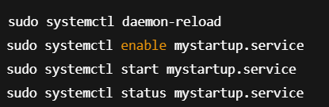

**Explanation:**

* **Reload Daemon:** Ensures that systemd picks up the new service file.
* **Enable Service:** Configures the service to start automatically on system boot.
* **Start Service:** Manually starts the service.
* **Check Status:** Verifies that the service is running as expected.

**8. Monitoring Service Logs**

* **Commands:**

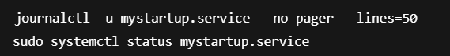

* **Explanation:**
  + These commands are used to monitor the service logs and status. This helps with troubleshooting and ensuring the service is operating correctly after deployment.

**Summary**

These commands collectively set up a cloud environment for the Live Streaming Platform by:

* Installing and managing the correct version of Node.js.
* Cloning and preparing the project code from GitHub.
* Configuring and managing the application as a systemd service for reliable startup and monitoring.
* Installing all necessary dependencies for both the frontend and backend.
* Enabling logging and status checks to facilitate maintenance and troubleshooting in a production environment.

# **Check out Deployed Service:**

1) select instance which we have made:

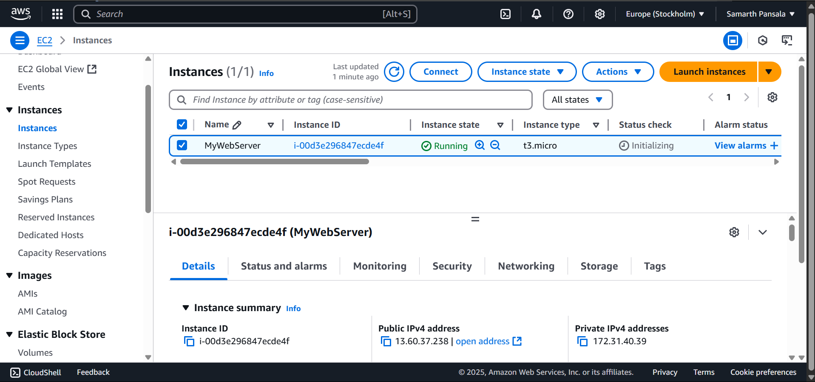

2) copy public Ip address of EC2 instance and paste it into browser with port number 8443 ( for example <https://[EC2> instance public IP addr.]:8443)

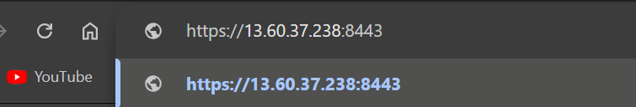

# Screen Shots of Live Streaming Web application :

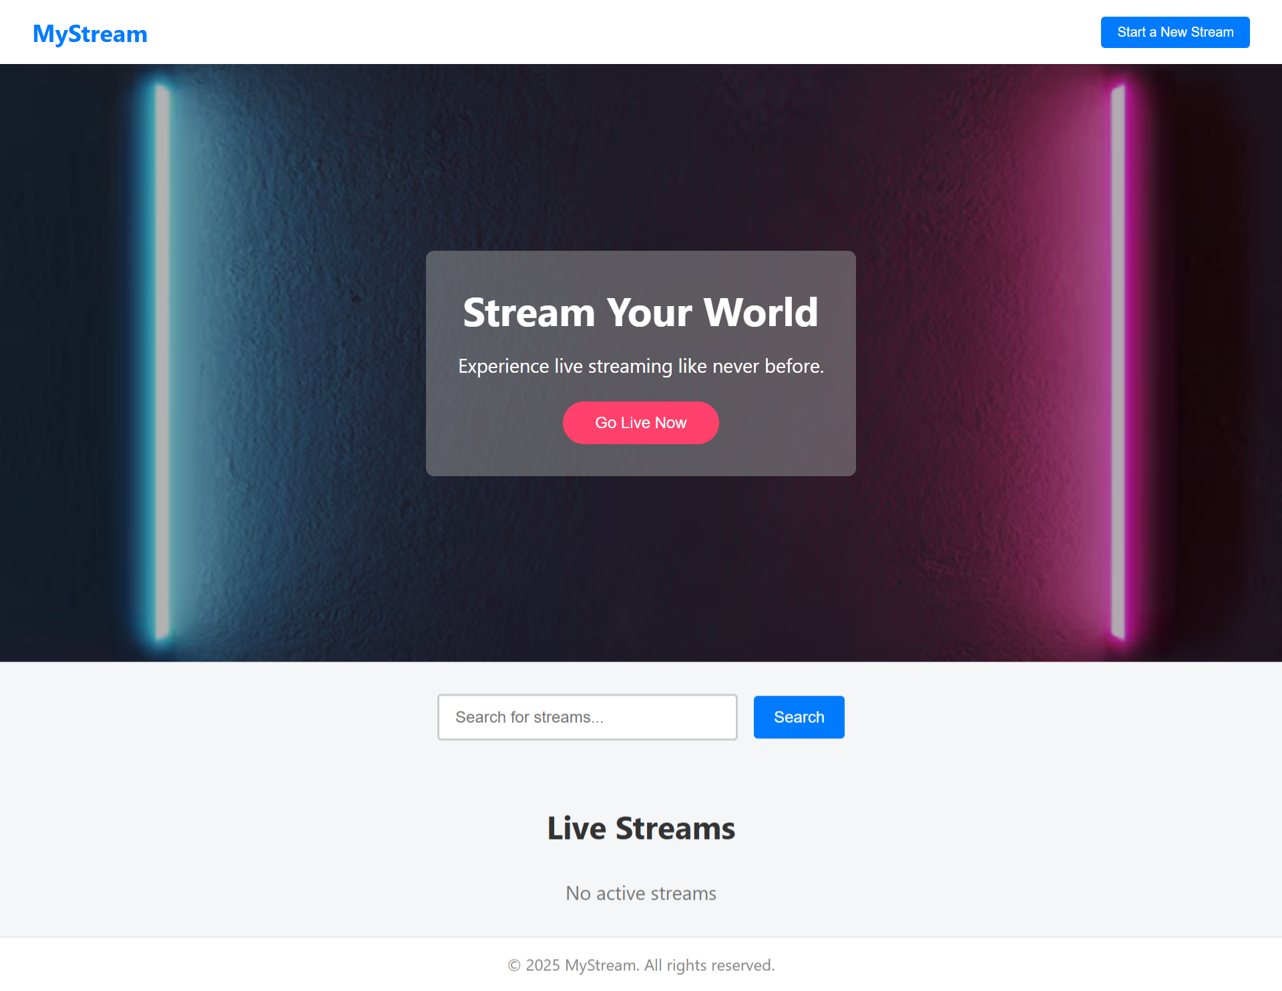

>>> Publisher:  
  
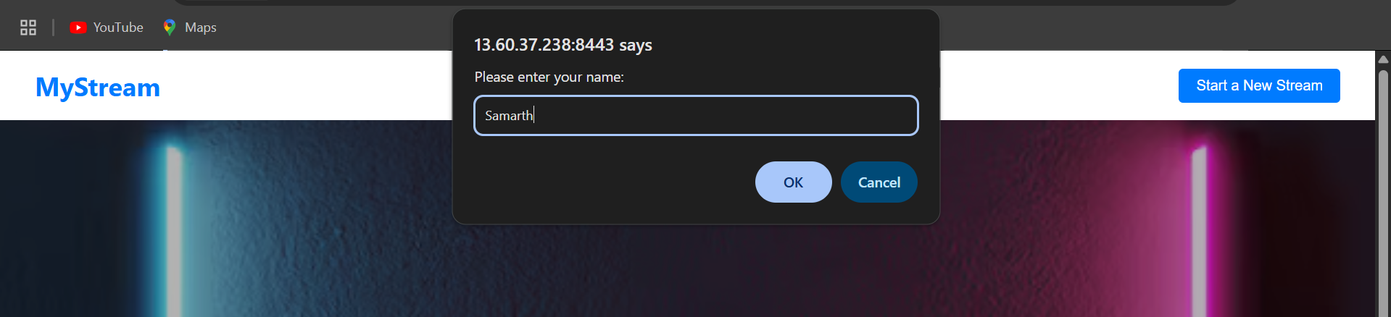  
  
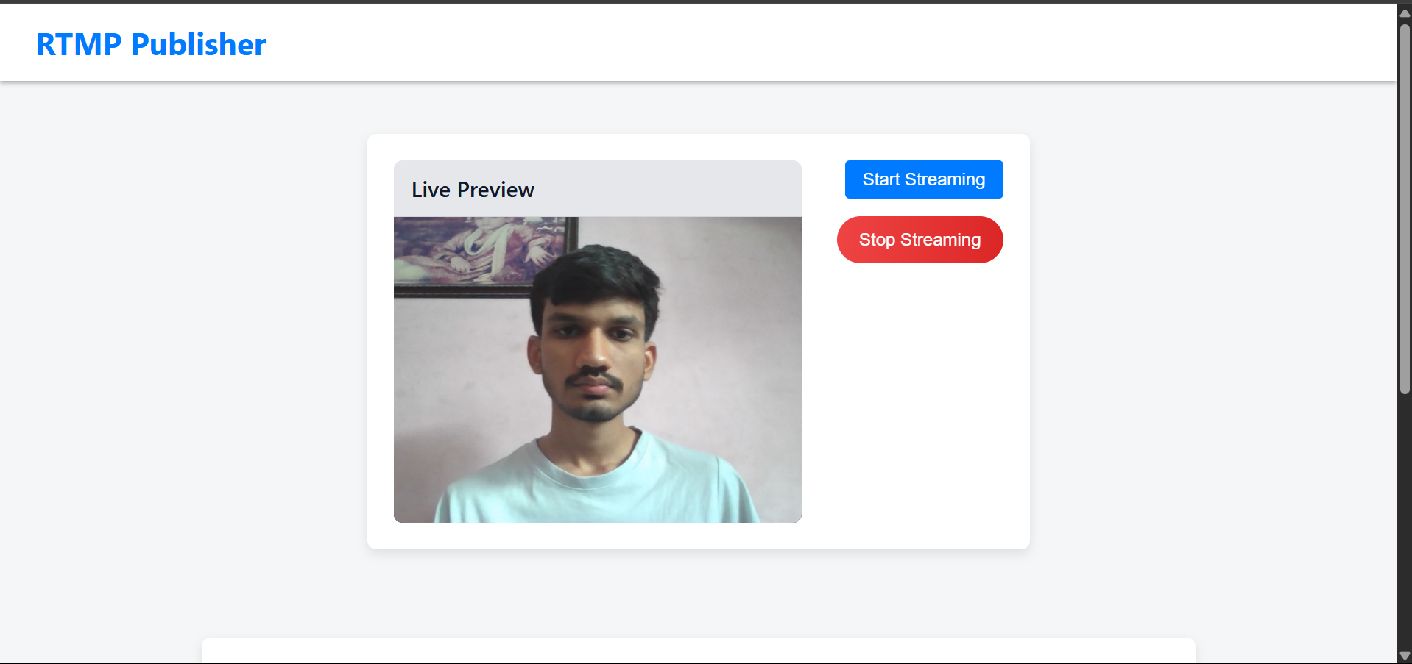  
  
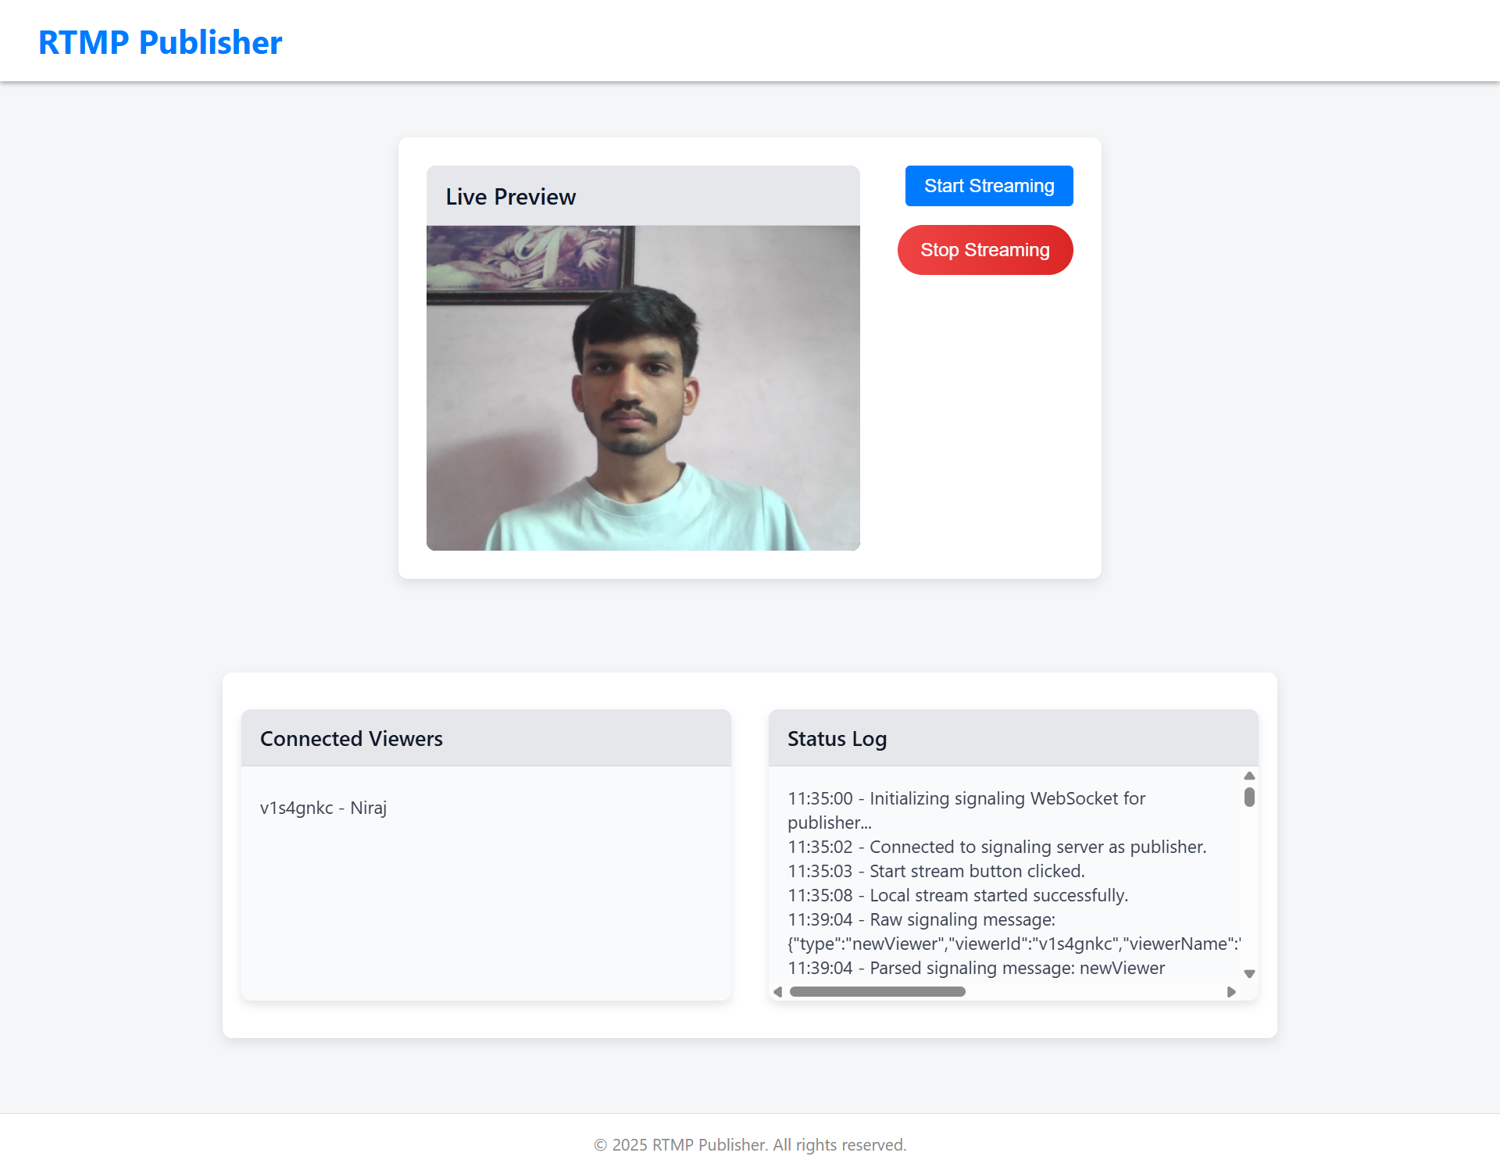  
  
  
>>> Viewer:::  
  
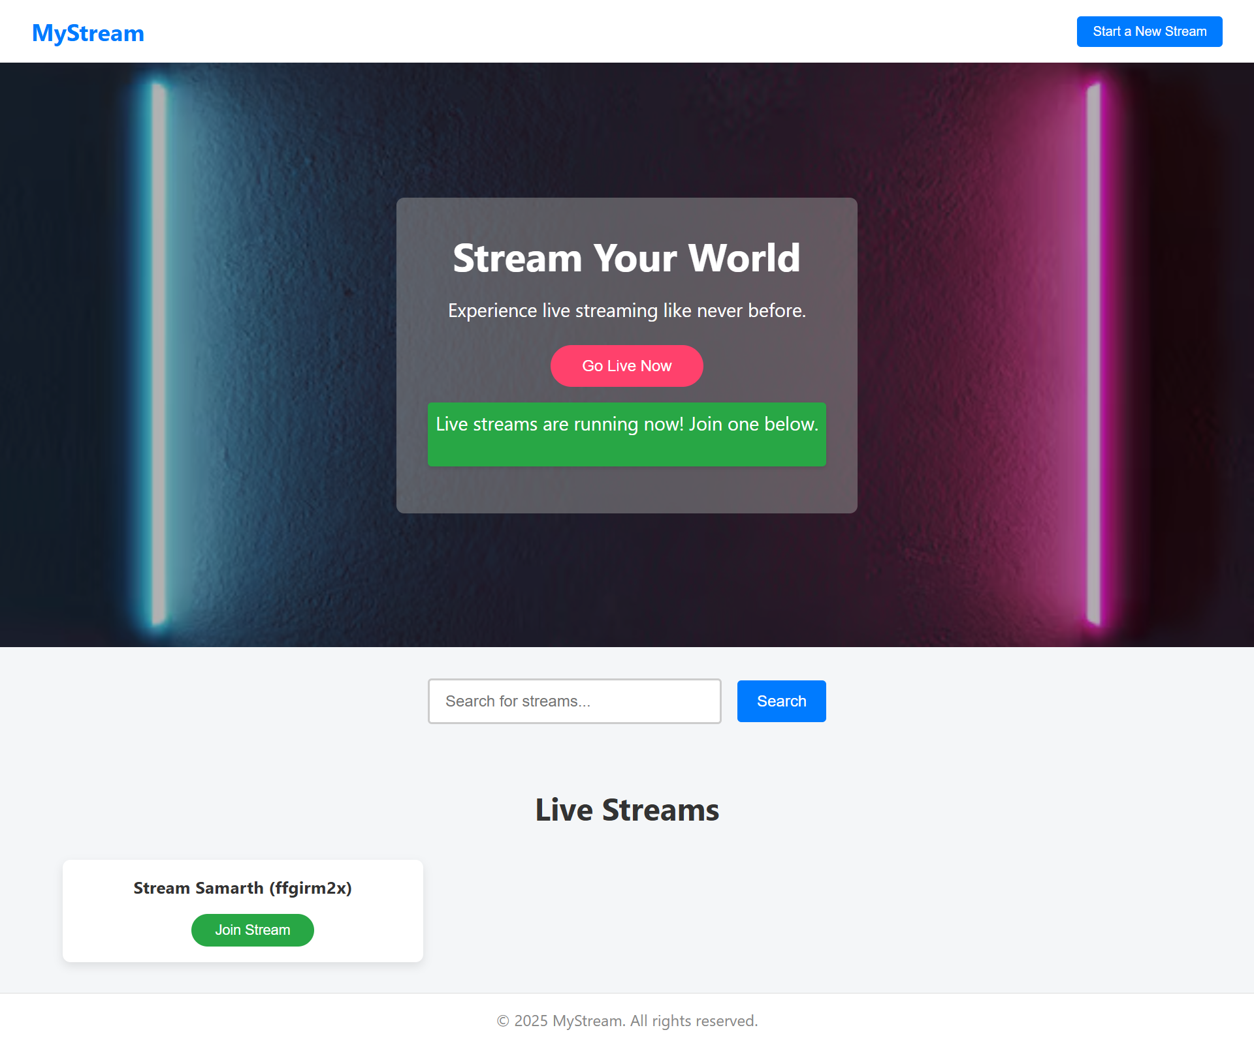  
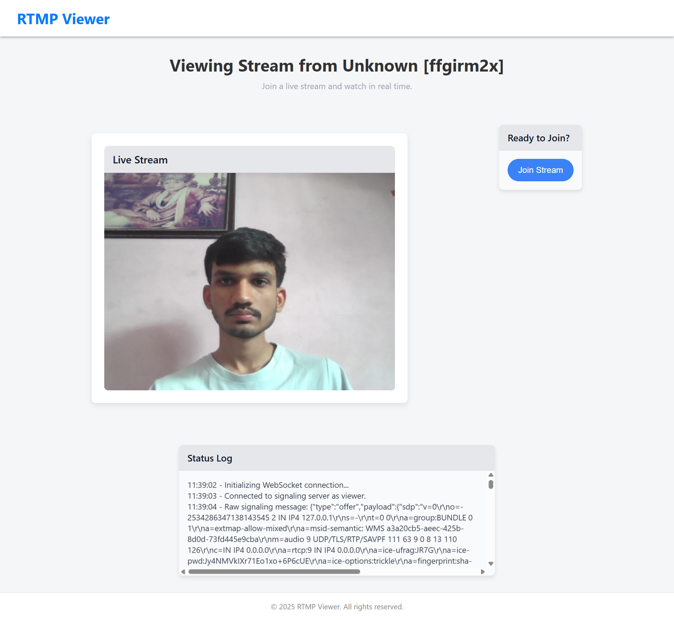

# Working

* Server Start:
  + Loads configurations, sets up HTTPS with Express, and starts listening on a secure port
* REST API:
  + Provides endpoints to list active streams and deliver ICE server configuration.
* WebSocket Connection:
  + Clients connect via WebSocket and announce their roles (publisher or viewer).
* Signaling Process:
  + Publishers and viewers exchange necessary WebRTC signaling messages (join, offer, answer, ICE candidates) via the WebSocket server.
* Session Management:
  + Active connections are tracked, and proper cleanup is performed when connections close.

# Conclusion:

cloud-based live streaming service exemplifies a modern SaaS solution by integrating secure, real-time communication with a user-friendly interface. Leveraging WebRTC for low-latency video and audio streaming, the system allows publishers to broadcast live content while viewers connect seamlessly, all underpinned by an HTTPS server that ensures secure data transmission. The architecture smartly separates signaling and media streaming, using WebSockets for real-time negotiation and REST APIs for stream management and ICE configuration. This modular design not only facilitates scalability and operational resilience but also aligns perfectly with SaaS principles by offering on-demand access, continuous updates, and cost-effective performance. Overall, the project stands as a robust, secure, and scalable platform for live streaming, capable of meeting the demands of diverse real-time applications.